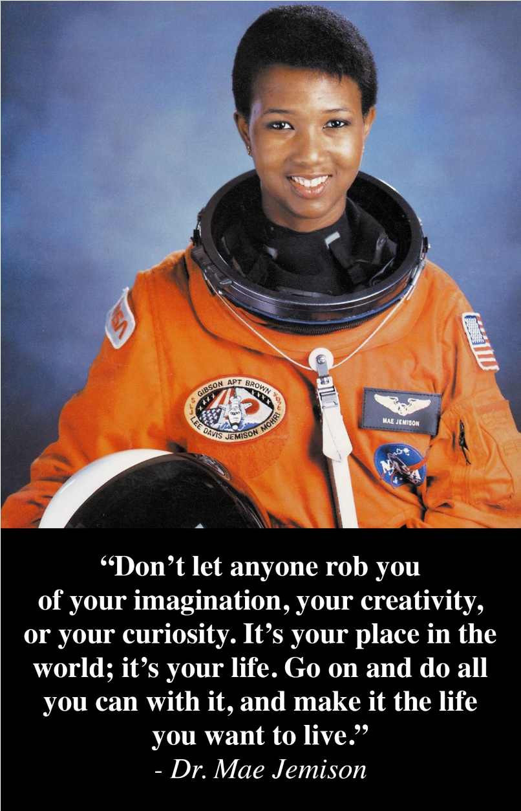
Great Minds: Dr. Mae Jemison
by Lydia Lukidis
Some people are driven by curiosity. They love to ask questions. They want to understand how everything works. This is the case with Dr. Mae Jemison. Ever since she was young, she always had the mind of a scientist.
Mae was born in the year 1956 in Decatur, Alabama. Her family moved to Chicago, Illinois a few years later. That way, she and her siblings got a better education. Her father was a roofer and a carpenter. Her mother was a school teacher. Both her parents encouraged their children to keep learning and follow their passion.
Mae’s mother even helped turn everyday events into science experiments. When Mae was young, a splinter infected her thumb. She observed pus oozing out. She was curious about this white stuff: what was it and why was it coming out? That simple incident turned into a learning experience. She ended up doing a whole project about pus.
It’s no surprise that Mae did well at school. Her curiosity and drive were natural. She graduated from high school with honors. Then she received a Bachelor of Science degree in chemical engineering. She got another degree in African and Afro-American Studies. Both were from Stanford University.
But Mae didn’t want to study or do just one thing. She wanted to explore many things. She chose to study medicine next at Cornell University Medical College. Then she officially became a doctor. In 1983, she joined the Peace Corps and went to West Africa. She was a medical officer in Sierra Leone and Liberia for over two years. That was a great adventure.
After this, Mae moved to Los Angeles and worked as a doctor. She enjoyed her job yet her childhood dream of going to space still lingered. She applied for admission to NASA's astronaut training program. NASA stands for National Aeronautics and Space Administration.
Believe it or not, she didn’t get in. The Challenger disaster delayed everything. But she didn’t give up. She applied again a year later. And this time, she was accepted! She was admitted into the NASA astronaut training program. Over 2,000 people had applied in total.
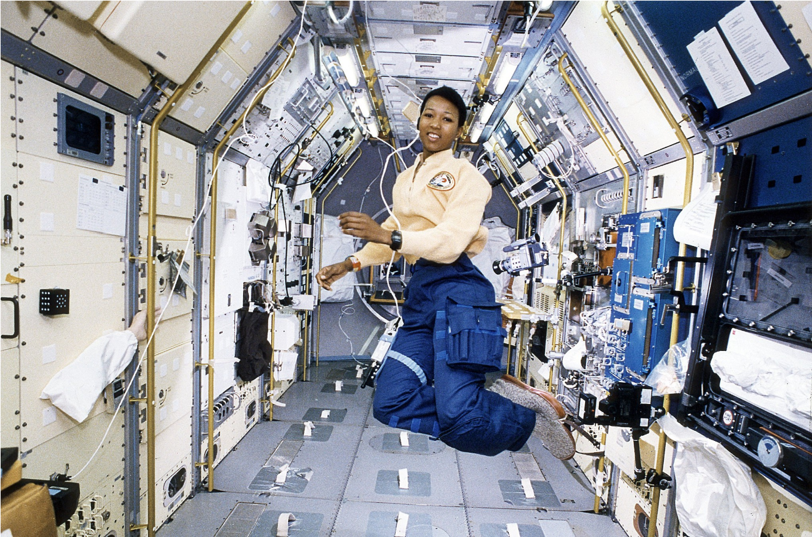
She was chosen along with fifteen other candidates.
And in 1992, her dream came true. She became the first African-American woman to go to space. She was joined by six other astronauts aboard the spaceship Endeavour. The
crew remained in space for a total of eight days. Their mission was called STS47. Mae conducted experiments on weightlessness and motion sickness on the crew and herself.
Shortly after her epic trip to space, she resigned from NASA to pursue other things. She became a teacher at Dartmouth College. She also formed The Jemison Group, a technology design and consulting
Dr. Mae Jemison working inside Space Shuttle Endeavour
company.
Through the course of her life, Mae was an accomplished doctor, scientist, astronaut, and explorer. She won many awards and honors. Although she is now retired, she’s still an activist. She also continues to speak at many conferences and schools. She talks about perseverance, using one’s potential, and the importance of pursuing one’s dreams. She also spreads the message that minority groups can contribute great things to the world. All they need is an opportunity.
Mae’s path wasn’t always easy. There were many obstacles. Some teachers didn’t approve of her studying science. At that time, many believed that women didn’t have a
place in the world of science. On top of that, she was an African American. She had to deal with racism. But nothing would stand in her way. She always believed in herself and her unlimited potential. This serves as inspiration for us all.

About the Author

Lydia Lukidis is a children's author with a multi-disciplinary background that spans the fields of literature, science, and theater. So far, she has over 40 books and eBooks published, as well as a dozen educational books. Her latest STEM books include A Real Live Pet! and The Space Rock Mystery.

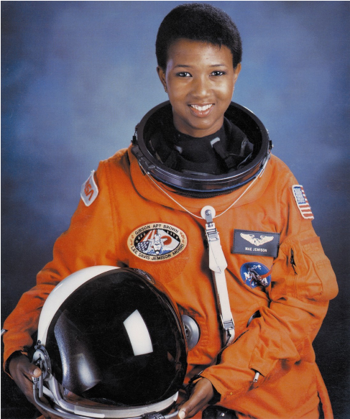
Great Minds: Dr. Mae Jemison
by Lydia Lukidis

- Based on the information in the article, describe the attitude Mae Jemison's parents had toward Mae's education.
___________________________________________________________________
___________________________________________________________________
___________________________________________________________________
- Mae Jemison was passionate about learning many different things. Identify three things Mae studied in college.
_____________________________________________________________________________________
_____________________________________________________________________________________

- What was significant about Mae Jemison's trip to outer space in 1992?
_____________________________________________________________________________________
_____________________________________________________________________________________
- Today Mae Jemison speaks at conferences and schools. What message does she bring to her audiences?
_____________________________________________________________________________________
_____________________________________________________________________________________
_____________________________________________________________________________________

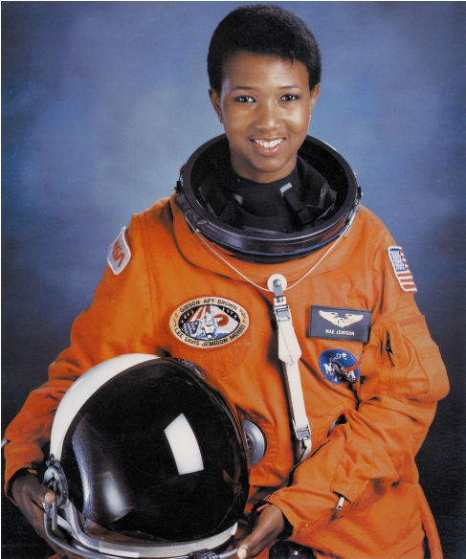
Great Minds: Dr. Mae Jemison
by Lydia Lukidis
The following terms are vocabulary words from the article.
Match the vocabulary word with its correct definition by writing the
corresponding letter on the line.

1.
_____ curiosity
a.
the science of air travel

2.

_____ carpenter
b.
people who apply for a job,
position, or program
3.
_____ splinter
c.
endurance; determination in the face of difficulties

4.
_____ Peace Corps
d.
a desire to learn about something

5.

_____ aeronautics
e.
discrimination or unfair treatment of someone based
on their race

6.
_____ activist
f.
a U.S. government-run volunteer program
7.
_____ perseverance
g.
a person who makes and repairs wooden objects
8.
_____ racism
h.
brothers and sisters
9.
_____ candidates
i.
a small, sharp piece of wood, glass, or metal that
lodges itself inside your skin and feels painful

10.
_____ siblings

j.
a person who works for social or political change

Great Minds: Dr. Mae Jemison

by Lydia Lukidis
In the article, “Great Minds: Dr. Mae Jemison,” you learned that Mae Jemison took an interest in many different fields of study. Each discipline she studied took her down a new path that helped make her an accomplished doctor, scientist, astronaut, explorer, and activist.
On the lines below, write about what you might want to study after you graduate from high school. What kind of career do you hope to have? What kind of impact or message do you want to share with the world?
__________________________________________________________________________________________
__________________________________________________________________________________________
__________________________________________________________________________________________
__________________________________________________________________________________________
__________________________________________________________________________________________
__________________________________________________________________________________________
__________________________________________________________________________________________
__________________________________________________________________________________________
__________________________________________________________________________________________
__________________________________________________________________________________________
__________________________________________________________________________________________
__________________________________________________________________________________________
__________________________________________________________________________________________

